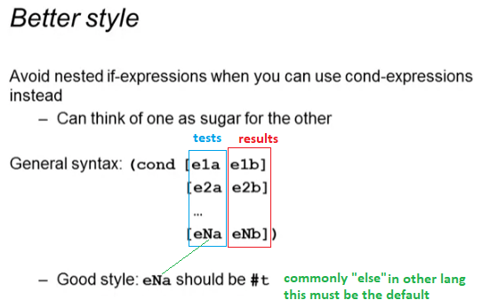

First example

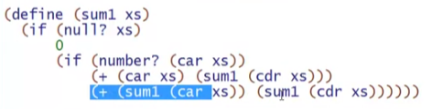

Counter part:

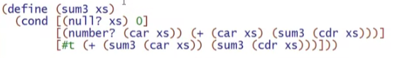

2nd example:

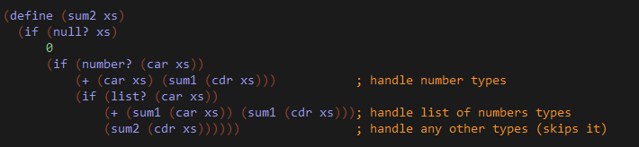

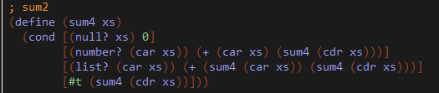

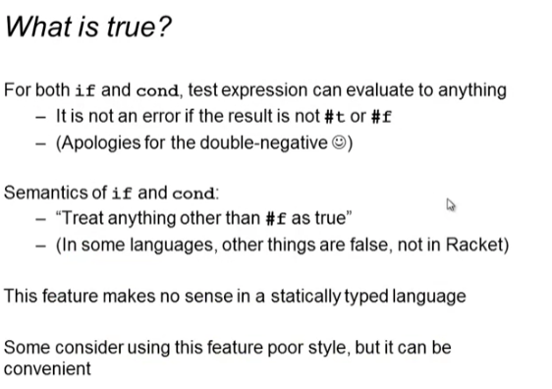

* #f is the ONLY FALSE statement in Racket, any other things (even if not Boolean type) will be TRUE

Example:

